Non-profit Organization # 223-001-297
PO Box 101
Bayville, NJ 08721
BGSLNJ@outlook.com

Season 2026

Dear Local Business Owner/Organization,

Berkeley Girls Softball League is a volunteer, non-profit, recreational organization that strives to offer an instructional, fun program for our players and their families. We emphasize the qualities of good sportsmanship, teamwork, integrity, and respect. All these lessons will aid in the development of the organization's youth into upstanding citizens. Our league consists of over 200+ players (ages 4-16), coaches, board members and growing.

On behalf of BGSL, we are proud to invite you to sponsor our league for the 2026 season. Your generous, tax deductible, donation will help us provide new equipment in order to keep the league competitive, safe, and properly running.

Your partnership is paramount and will enable us to provide a healthy, positive environment for the young ladies of Berkeley Township to learn the fundamentals of softball. Essentially with the donation you will enter into a 2-year contract. Each advertisement below indicates 1st and 2nd year costs respectively.

Cost savings program offers ALL 3 packages: 1st Year $500 and 2nd Year $300

BANNER ADVERTISEMENT: 1st Year $300 2nd Year $150

- 3 x 5 Full Color metal composite sign with your business logo and contact information which will hang prominently in Veterans Park on the fence of one of our diamonds.

FAN GEAR T-SHIRT: 1st Year $200 2nd Year $150

- Your business logo will be added to the back of our annual fan gear t-shirt that is given out to all players, board, and available for purchase for coaches and family members.

- INTERNET ADVERTISEMENT ON BGSL WEBSITE: $50.00 Annually
Your business logo that can link to your website posted on our home page of www.berkeleygirlssoftball.com under our sponsors, for 1 year
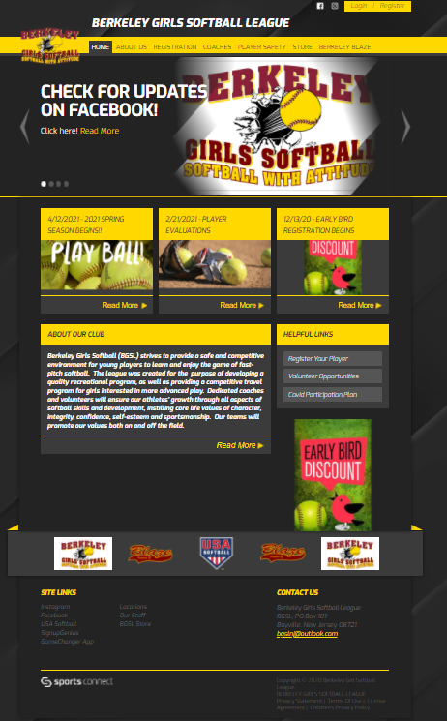
Thank you in advance for-your time, consideration, and donation!
Jeff Saunders, President
Jaime D’Auria, Vice President
Jessica Gojdycz, Secretary
Joe McGinley, Treasurer
Chris Gojdycz, Scheduler
Kevin Hibberd, Equipment Manager
Amanda Matthews, Concession Manager
  - Dawn McGinley, Concession Assistant
Sharon Villa , Fundraising Assistant
Brad Chadwick, Information Manager
Kia Phua, Field Crew
Justin Krieg, Field Crew
Adam Guker, Field Crew
Victor Applegate, Field Crew
Larry Difabio, Field Crew
Dave Leonard, Board Member At Large
Megan Ornstein, Board Member At Large
Melissa Witte, Board Member At Large
Holly Hibberd, Board Member At Large
Steve DeLorenzo, Board Member At Large

PO Box 101
Non-profit Organization # 223-001-297
Bayville, NJ 08721
BGSLNJ@outlook.com

Sponsorship Donation Submittal Form

Cost savings program offers ALL 3 packages: 1st Year $500 and 2nd Year $300

BANNER ADVERTISEMENT: 1st Year $300 2nd Year $150

- 3 x 5 Full Color metal composite sign with your business logo and contact information which will hang prominently in Veterans Park on the fence of one of our diamonds.

FAN GEAR T-SHIRT: 1st Year $200 2nd Year $150

- Your business logo will be added to the back of our annual fan gear t-shirt that is given out to all players, board, and available for purchase for coaches and family members.

INTERNET ADVERTISEMENT ON BGSL WEBSITE: $50.00 Annually

- Your business logo that can link to your website posted on our home page of www.berkeleygirlssoftball.com under our sponsors, for 1 year

Please email all artwork to the email above.

Business Name: ____________________________________________________

Contact Person: ____________________________________________________

Phone Number: ____________________________________________________

Address: __________________________________________________________

Email: ____________________________________________________________

Amount: First year: __________ Second Year: __________

Method of Payment: __________ CASH __________ CHECK#___________

